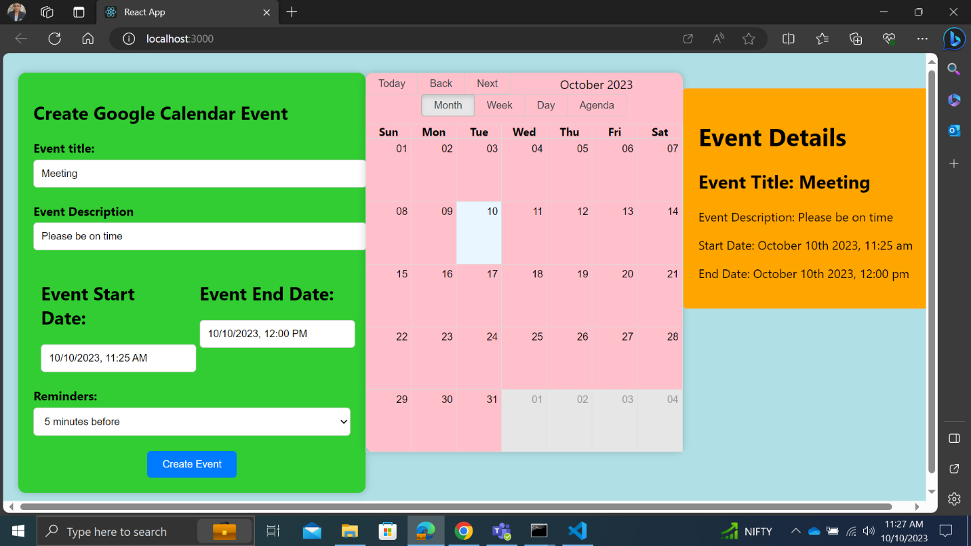

1. This is the output of the project

1. This is the node server running of the project

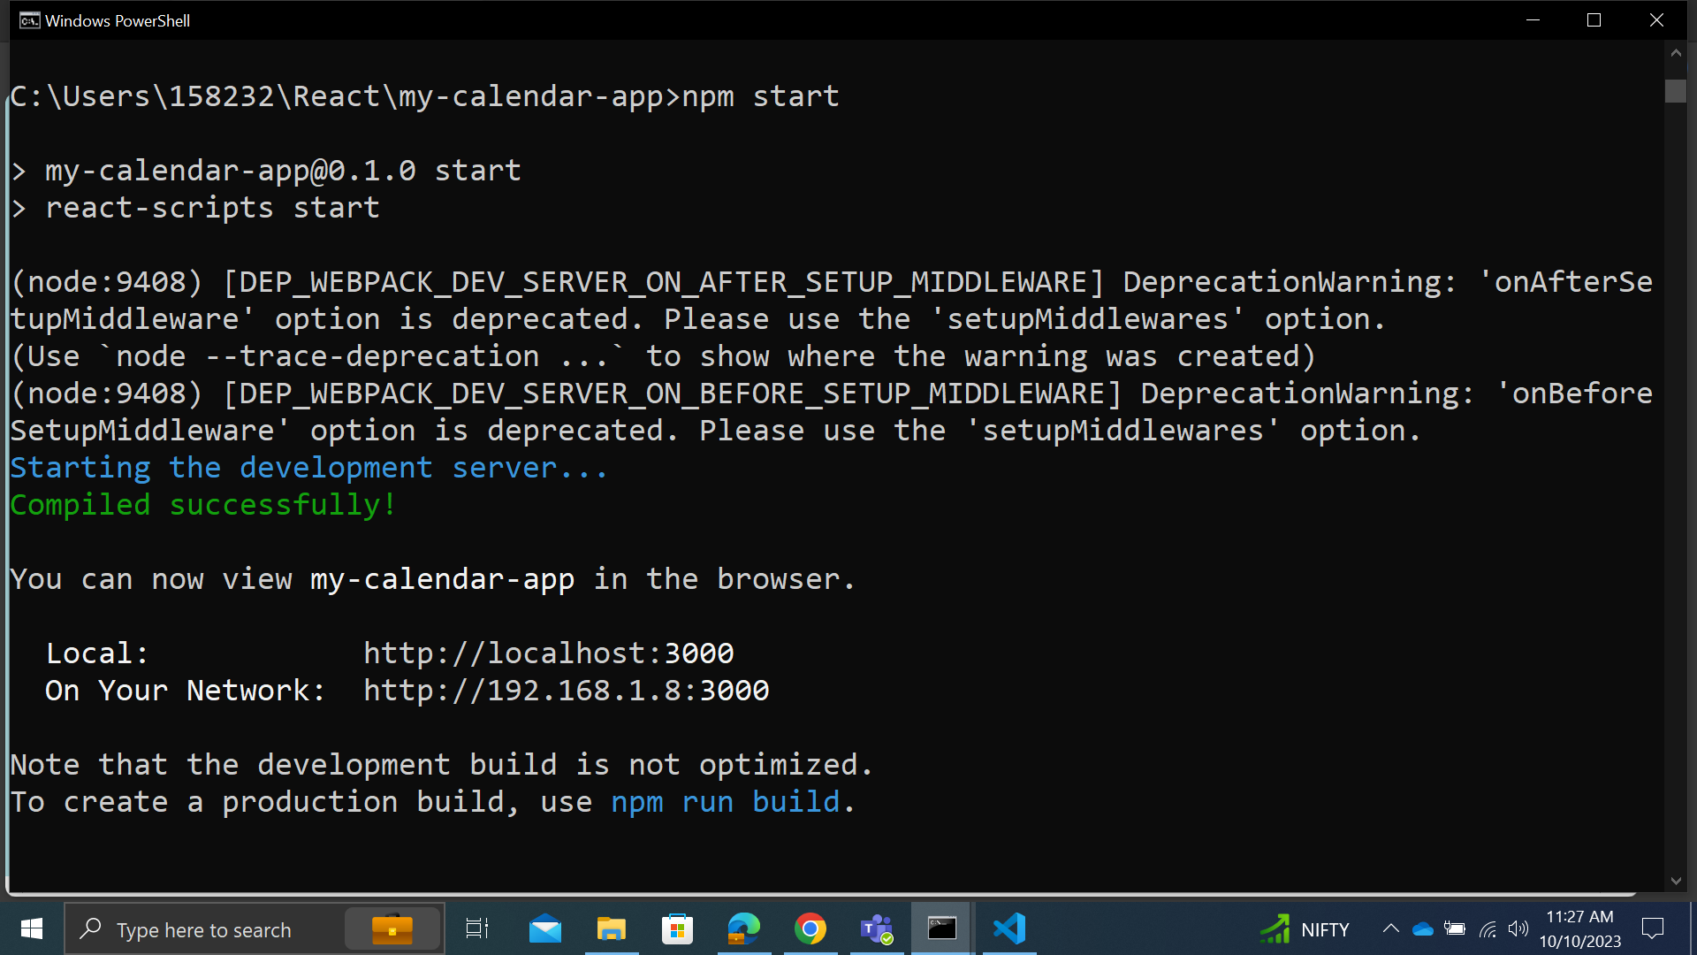

1. This is the react part of the running the project